Project Design Phase
Solution Architecture
Date | 15 February 2025
Team ID | SWTID-2026-8331
Project Name | Team Enrollment Confirmation – Import Data using Transform Maps (Spreadsheet)
Maximum Marks | 4 Marks
Solution Architecture:
The solution imports team enrolment data from a spreadsheet into ServiceNow using Import Sets and Transform Maps, validates it, and confirms enrolment automatically. The architecture bridges the business problem (slow, error-prone manual entry) and the technology solution. Its goals are to:
- Find the best tech solution to eliminate manual, error-prone data entry.
- Describe the structure, characteristics and behaviour of the solution to project stakeholders.
- Define features, development phases and solution requirements.
- Provide specifications according to which the solution is defined, managed and delivered.
Solution Architecture Diagram:
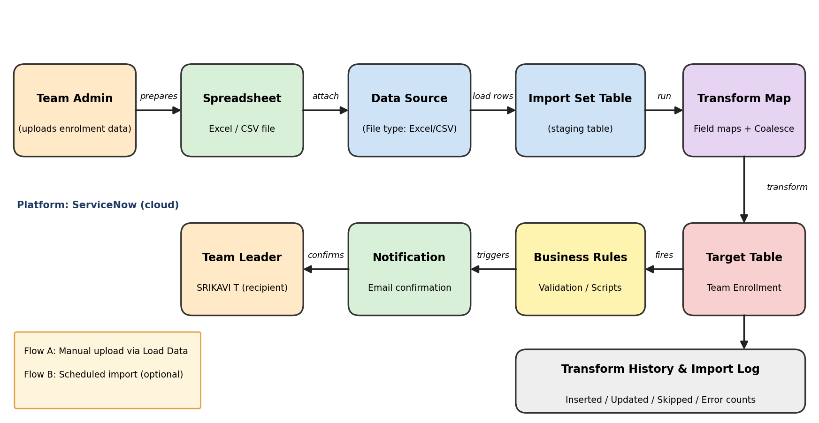
Figure 1: Architecture and data flow of the Team Enrollment import using Transform Maps
Components
S.No. | Component | Description
1 | Team Admin / User | Prepares the enrolment spreadsheet (Team ID, team size, leader, members) and starts the import.
2 | Spreadsheet (Excel/CSV) | Source file that holds the team enrolment records to be imported.
3 | Data Source | ServiceNow record that points to the uploaded file and defines its format and header row.
4 | Import Set Table | Staging table where the raw spreadsheet rows are loaded before any changes are made.
5 | Transform Map | Maps each staging column to a target field; Team ID is set as the coalesce field to prevent duplicates.
6 | Business Rules / Transform Scripts | Validate and clean data (mandatory fields, trimming, team size check) during onBefore/onAfter events.
7 | Target Table (Team Enrollment) | Final table storing confirmed enrolment records.
8 | Notification | Email confirmation sent to the team leader after successful insert or update.
9 | Transform History & Import Log | Reports inserted, updated, skipped and error counts for audit and troubleshooting.
Data Flow
- The admin prepares the spreadsheet with columns such as Team ID, Team Size, Team Leader and Team Member names.
- The file is uploaded through System Import Sets > Load Data, creating a Data Source and loading rows into the Import Set staging table.
- A Transform Map matches spreadsheet columns to Team Enrollment fields and coalesces on Team ID, so existing teams are updated instead of duplicated.
- Transform scripts and business rules validate every row; invalid rows are skipped and logged.
- Valid rows are inserted or updated in the Team Enrollment table.
- A notification email confirms enrolment to the team leader, and the Transform History records the results.
Technology Stack
Layer | Technology
Platform | ServiceNow (cloud-based, Now Platform)
Import features | Import Sets, Data Sources, Transform Maps, Field Maps, Coalesce
Data format | Microsoft Excel (.xlsx) / CSV
Automation | Business Rules, Transform Scripts (JavaScript), Email Notifications
Monitoring | Transform History, Import Set Rows, System Logs
Team Details
Role | Name
Team Leader | SRIKAVI T
Team Member | ISWARYA S
Team Member | YOGASRI S
Team Member | KEERTHIKA L
Team ID: SWTID-2026-8331 | Team Size: 4 | Project files: https://drive.google.com/drive/folders/1YpCUwkQuALCmuGVehWFcmxaglr-0dZCD

